GUIDELINES FOR B.Tech PROJECT REPORT

- The project report shall be computer typed (English- British, Font -Times Roman, Size-12 point) and printed on A4 size paper.
- The project report shall be typed on one side only with double space with a margin 3.5 cm on the left, 2.5 cm on the top, and 1.25 cm on the right and at bottom.
- The length of the overall document should be around 70 to 80 pages for it to be an effective project report.
- In the project report, the title page should be given first then the Certificate by the candidate and the supervisor(s) in sequence, followed by an abstract of the project report (not exceeding 1000 words). This should be followed by the acknowledgment, list of figures/list of tables, notations/nomenclature, and then contents with page no.
- In the body of the text, a reference should be indicated giving author name and year of publication in parenthesis such as (Singh and Shan, 2002).
- The reference should be given at the end of the Project report in alphabetical order indicating:
- a) The authors name and his initials
b) The title of the paper and name of the journal
c) The name of the book and the publisher
d) The number of the volume, page numbers, and the year of publication
e) standard abbreviation may be used in the names of the journals

For Reference Example:

  - Singh, S. and Shan, H. S. (2002) “Development of Magneto Abrasive Flow Machining Process”, International Journal of Machine Tools & Manufacturing, vol. 42, 2, 2002, pp. 953-959.
VirtualVeins: Analysis on impact of social media on human brain

A
Project Report
submitted
in partial fulfilment
for the award of the Degree of
Bachelor of Technology
in
Computer Science and Design


Supervisor: Submitted By:
Dr. Sonia Juneja Faizaan Khan (2101431650011)
Hod, CS/CSD Garvit Garg (2101431650012)
Garvit Goel (2101431650013)
Himanshu Daksh (2101431650016)

Department of Computer Science and Design
IMS Engineering College, Ghaziabad (U.P)
Dr. A.P.J Abdul Kalam Technical University, Uttar Pradesh, Lucknow.
December, 2024

Vision and Mission of the Institute and Department

Vision of the Institute
“To make IMSEC an Institution of Excellence for empowering students through technical education, incorporating human values, and developing engineering acumen for innovations and leadership skills to upgrade society.”

Mission of the Institute
- To promote academic excellence by continuous learning in core and emerging Engineering areas using innovative teaching and learning methodologies.
- To inculcate values and ethics among the learners.
- To promote industry interactions and produce young entrepreneurs.
- To create a conducive learning and research environment for life-long learning to develop the students as technology leaders and entrepreneurs for addressing societal needs.
Vision of the Department
To produce technocrats for designing technology-based solutions with sound ethics, innovative mindset and leadership skills required for the sustainable development of the Nation.

Mission of the Department

M1: To develop understanding of design principles and techniques in the domain of computer science and their applicability for developing innovative solution to real world problems.

M2: To provide an environment of collaborative learning for developing technical and leadership skills among graduates.

M3: To produce graduates who are competent in their profession, exhibit ethics with a responsible attitude towards the nation.

CO-PO-PSO Mapping

Course Name: Project AKTU Course Code: KCS753
Semester / Year: VII/ 4th NBA Code: C407
Subject Coordinator: Mr. Awdhesh Kumar

Course Outcomes:

CO. No. | DESCRIPTION | COGNITIVE LEVEL (BLOOMS TAXONOMY)
C407.1 | Analyze and understand the real-life problem and apply their knowledge to get programming solution. | K4 , K5
C407.2 | Engage in the creative design process through the integration and application of diverse technical knowledge and expertise to meet customer needs and address social issues. | K4 , K5
C407.3 | Use the various tools and techniques, coding practices for developing real life solution to the problem. | K5 , K6
C407.4 | Find out the errors in software solutions and establishing the process to design maintainable software applications | K4 , K5
C407.5 | Write the report about what they are doing in project and learning the team working skills | K5, K6

CO-PO-PSO Mapping:

 | PO1 | PO2 | PO3 | PO4 | PO5 | PO6 | PO7 | PO8 | PO9 | PO 10 | PO 11 | PO 12 | PSO1 | PSO2
C407.1 | 3 | 3 | 3 | 3 | 3 | 1 | 1 | 2 | 2 | 3 | 3 | 3 | 3 | 3
C407.2 | 3 | 3 | 3 | 3 | 3 | 1 | 1 | 2 | 2 | 3 | 3 | 3 | 3 | 3
C407.3 | 3 | 3 | 3 | 3 | 3 | 1 | 1 | 2 | 2 | 3 | 3 | 3 | 3 | 3
C407.4 | 3 | 3 | 3 | 3 | 3 | 1 | 1 | 2 | 2 | 3 | 3 | 3 | 3 | 3
C407.5 | 3 | 3 | 3 | 3 | 3 | 1 | 1 | 3 | 3 | 3 | 3 | 3 | 3 | 3
Avg. | 3 | 3 | 3 | 3 | 3 | 1 | 1 | 2.2 | 2.2 | 3 | 3 | 3 | 3 | 3

Candidate’s Declaration

I hereby declare that the work, which is being presented in the Project, entitled “Impact of social media on human brain” in partial fulfillment for the award of Degree of “Bachelor of Technology” in Computer Science and Design, and submitted to the Department of Computer Science and Design, IMS Engineering College, Ghaziabad, affiliated to Dr. A.P.J Abdul Kalam Technical University, Uttar Pradesh, Lucknow is a record of my own investigations carried under the Guidance of Dr. Sonia Juneja Hod CS/CSD, IMS Engineering College, Ghaziabad.

I have not submitted the matter presented in this Project anywhere for the award of any other Degree.

Faizaan Khan (2101431650011)
Garvit Garg (2101431650012)
Garvit Goel (2101431650013)
Himanshu Daksh (2101431650016)
Computer Science and Design
IMS Engineering College, Ghaziabad

This is to certify that the above statement made by the candidate(s) is correct to the best of my/our knowledge

Counter Signed by

Dr. Sonia Juneja
Hod , CS/CSD
IMS Engineering College, Ghaziabad

CERTIFICATE

This is certified that the Project entitled “Impact of social media on human brain” submitted to IMS Engineering College, Ghaziabad, affiliated to Dr. A.P.J Abdul Kalam Technical University, Uttar Pradesh, Lucknow for the award of the Degree of Bachelor of Technology in Computer Science and Design is a record of bonafide work carried out by him under my supervision. In my opinion, the dissertation has reached the standards of fulfilling the requirements of the regulations to Degree.

Dr. Sonia Juneja
Hod, CS/CSD
IMS Engineering College, Ghaziabad

ACKNOWLEGEMENT

First and foremost, I would like to express my sincere gratitude to my project supervisor Dr. Sonia Juneja, Hod CS/CSD, IMS Engineering College, Ghaziabad, who gave me this opportunity with important guidelines regarding various points to be taken for my project work and also for his deep involvement, precious advices, valuable suggestions and continuous motivation throughout this work. I am highly obliged to him for always being there in my needs. I consider myself very fortunate for having been associated with the supervisor like him. His affection, guidance and scientific approach served a veritable incentive for completion of this work.

I express my sincere gratitude to Prof. (Dr.) Sonia Juneja, HoD in Department of Computer Science and Design, IMSEC, Ghaziabad, for his stimulating guidance, continuous encouragement and supervision throughout the course of present work.
I also wish to extend my thanks to Mr. Awdesh Kumar for their insightful comments and constructive suggestions to improve the quality of this research work.
I am extremely thankful to Prof. (Dr.) Shailesh Tiwari, Director, IMSEC, Ghaziabad, for providing me infrastructural facilities to work in, without which this work would not have been possible.
I would also like to express my genuine gratitude to Project Coordinator Mr. Awdhesh Kumar for his valuable suggestions and advices in carrying out this work.
I also like to thank the entire institute faculty who helped me directly or indirectly to complete my work

This acknowledgement will remain incomplete if fail to express my deep sense of obligation to my family and God for their consistent blessings and encouragement.

Faizaan Khan (2101431540011)
Garvit Garg (2101431650012)
Garvit Goel (2101431650013)
Himanshu Daksh (2101431650016)
Table of Contents

Vision and Mission iii
CO-PO-PSO Mapping iv
Candidate’s Declaration v
Certificate vi
Acknowledgement vii
Table of contents viii
List of Figures ix
List of Tables …………………………………………………………………….………..…...x
ABSTRACT
Chapter 1 INTRODUCTION
  - Problem Identification…………………………………………………….…….
  - Detail Problem Definition ……………………………………………….……..
  - Current Market Survey ……………………………..…………………………...
  - Advantages ……………………………………………….…………………….
Chapter 2 LITERATURE SURVEY………………………………………………………..
  - Base Paper 1 ………………………………………………..………………….
  - Base Paper 2 …………………………………………………..……………….
  - Base Paper 3 …………………………………………………….…………….
Chapter 3 METHODOLOGY ……………………………………………………………...
Chapter 4 IMPLEMENTATION …………………………………………………………..
Chapter 5 Analysis & Design ………………………………………………………...
Chapter 6 Results & Discussion…………………………………………………….
Chapter 7 CONCLUSION & FUTURE PROSPECTS
REFERENCES
APPENDIX – A: LIST OF PUBLICATIONS / PATENT

List of Figures

Figure No. | Caption of the figure | Page No
Fig.1
Fig.2
Fig.3
Fig.4
Fig.5
Fig.

List of Tables

ABSTRACT

The project "Impact and Effect of Social Media on the Human Brain" delves into the cognitive, emotional, and behavioral effects of social media usage. With platforms like Twitter, Facebook, and Instagram becoming integral to daily life, their impact on mental health has emerged as a pressing concern. This study examines how prolonged exposure to social media correlates with mental health indicators such as anxiety, depression, and attention span. Furthermore, it explores the role of sentiment within social media content in shaping user emotions, behaviors, and cognitive functions.
To achieve these objectives, the project employs cutting-edge technologies, including machine learning, and advanced data visualization techniques. Social media data will be collected using APIs from popular platforms, focusing on user-generated content, engagement metrics, and interaction patterns. Sentiment analysis will categorize content into emotional spectrums such as happiness, anger, and sadness, while cognitive load estimation algorithms will assess the mental strain caused by varying usage patterns. Statistical analysis and predictive modeling will further uncover correlations and forecast potential outcomes of social media consumption on mental health.
The outcomes of this project are multifaceted. Interactive dashboards will provide real-time visualizations of data, highlighting trends and key findings. Comprehensive reports will offer actionable insights for users, mental health professionals, and developers. These findings can help users identify harmful social media habits and adopt healthier practices. For therapists and counselors, the tools can serve as diagnostic aids for patients affected by social media-induced stress or anxiety. Additionally, developers and platform managers can leverage these insights to design algorithms that prioritize user well-being.

CHAPTER 1
INTRODUCTION

Social media has become an inseparable part of modern life, revolutionizing how individuals communicate, share, and consume information. Platforms like Twitter, Facebook, Instagram, and TikTok have transcended their initial roles as communication tools to become influential ecosystems shaping personal, social, and cultural identities. While social media has facilitated unprecedented connectivity and innovation, its pervasive presence raises critical concerns about its impact on mental health, cognitive function, and emotional well-being.
The human brain is remarkably adaptable, but it is also vulnerable to the effects of prolonged exposure to digital environments. Studies suggest that excessive social media usage may be linked to adverse mental health outcomes such as anxiety, depression, and stress. Moreover, the continuous consumption of curated and emotionally charged content can alter attention spans, decision-making processes, and even self-perception. Understanding these implications is essential in today’s digital-first world, where billions of people engage with social media daily.
This project seeks to investigate the nuanced relationship between social media usage and its cognitive, emotional, and behavioral impacts. Specifically, it explores how various patterns of usage influence mental health indicators, emotional states, and cognitive functions. By leveraging technologies like machine learning, and data visualization, this study aims to identify actionable insights and contribute to developing healthier digital practices.
The significance of this research extends beyond individual users. It addresses broader societal concerns, such as the role of social media in shaping public discourse, its influence on younger generations, and its implications for public health. By integrating scientific analysis with practical applications, this project aims to foster a balanced understanding of social media's potential—both as a tool for positive engagement and a source of cognitive and emotional challenges.
This introduction sets the stage for a comprehensive exploration of social media's effects on the human brain, emphasizing the need for awareness, actionable solutions, and responsible platform design to ensure a healthier digital future.

  - Problem Identification

The evolution of social media has introduced several psychological and cognitive challenges. The accessibility of platforms ensures constant connectivity, but this has also blurred boundaries between personal and professional lives. Key problems include:

- Mental Health Concerns: Studies have linked excessive social media use to mental health issues like anxiety, depression, and stress. Younger demographics, particularly adolescents, are most vulnerable, as they are still developing emotional and cognitive maturity.
- Addictive Behavior: Social media platforms are designed to maximize user engagement, often leading to addictive patterns. Features like endless scrolling, notifications, and personalized feeds create a cycle of reward and dependency.
- Emotional Impact: Content shared on social media can evoke strong emotional responses. Negative content, such as cyberbullying or inflammatory posts, can contribute to emotional distress, while idealized representations of life may lead to feelings of inadequacy or poor self-esteem.
- Cognitive Impairments: Prolonged multitasking on social media is linked to reduced attention spans and difficulty focusing. These cognitive issues are particularly concerning in younger users, whose brains are still developing.
  - Detailed Problem Definition

The problems associated with social media usage are multifaceted and interconnected. This project focuses on the following areas:

- Mental Health Indicators:
  - Anxiety and Depression: Users often experience heightened anxiety due to constant comparisons, exposure to negative content, and the pressure to maintain an online persona.
  - Stress: The constant influx of information and notifications can overwhelm users, leading to chronic stress.
- Emotional Influence:
  - Sentiment Analysis: Social media content can range from highly positive to deeply negative. Understanding how this spectrum influences user emotions is critical.
  - Emotional Contagion: Studies suggest that emotions expressed on social media can "spread" to other users, amplifying both positive and negative moods.
- Behavioral Patterns:
  - Overuse: Users often lose track of time while scrolling, leading to decreased productivity and sleep deprivation.
  - Social Comparison: Viewing idealized lives on social media fosters unhealthy comparisons, negatively affecting self-esteem and body image.
- Cognitive Effects:
  - Reduced Attention Span: Social media's fast-paced nature encourages multitasking, reducing users' ability to focus deeply on tasks.
  - Cognitive Load: The constant barrage of information increases mental effort, leading to fatigue and impaired decision-making.

  - Current Market Survey

The increasing prevalence of mental health concerns associated with social media has led to a growing demand for tools and technologies that address these challenges. Key trends in the market include:
- Mental Health and Wellness Tools:
  - The mental health market is projected to grow to $560 billion by 2030. Digital solutions, including apps and monitoring tools, are becoming increasingly popular among individuals and healthcare providers.
  - Existing tools, such as Calm and Headspace, focus on general well-being but lack specific features addressing social media's cognitive and emotional impacts.
- Social Media Analytics:
  - The social media analytics industry, valued at $9.4 billion by 2026, emphasizes sentiment analysis and user behavior tracking. However, these tools are primarily designed for marketing purposes rather than mental health monitoring.
- Public and Educational Initiatives:
  - Governments and educational institutions are investing in awareness campaigns to highlight the adverse effects of excessive social media use. Tools that provide actionable insights could significantly enhance these efforts.
- Corporate Wellness Programs:
  - With the corporate wellness market expected to reach $87 billion by 2026, organizations are seeking tools to help employees manage their digital habits and mental health. This project aligns well with such initiatives, offering a unique perspective on digital well-being.

Despite the availability of some tools, there is a noticeable gap in comprehensive systems that integrate mental health monitoring with social media usage patterns. This project aims to address this gap by providing holistic solutions.

  - Advantages

The project offers several key advantages, making it a unique and valuable contribution to addressing the challenges of social media usage:
- Comprehensive Approach:
  - Unlike existing tools that focus on isolated aspects, this project integrates mental health monitoring, sentiment analysis, and cognitive load assessment into a single platform. This holistic approach provides a deeper understanding of social media's impact.
- Personalized Insights:
  - The system analyzes individual usage patterns to provide tailored recommendations. This personalization helps users identify harmful behaviors and adopt healthier practices.
- Real-Time Analysis:
  - By employing machine learning and natural language processing, the system offers real-time insights into user behavior and emotional states. Interactive dashboards allow users to track changes over time.
- Broader Applications:
  - The findings of this project have applications in multiple domains, including public health, education, and corporate wellness. Therapists and counselors can use the insights for diagnosis and treatment, while developers can design more user-friendly social media algorithms.
- Public Awareness:
  - The project contributes to broader public health campaigns by highlighting the mental health risks of excessive social media use. Clear, data-driven visualizations make the findings accessible to a wide audience.

CHAPTER 2
LITERATURE SURVEY

2.1 Base Paper 1

Title: Association Between Social Media Use and Depression Among U.S. Young Adults
Authors: Lin, L.Y., Sidani, J.E., Shensa, A., Radovic, A., Miller, E., Colditz, J.B., Hoffman, B.L., Giles, L.M., & Primack, B.A.
Published In: Journal of Preventive Medicine
Key Findings:
This paper investigates the association between social media usage and depression among young adults in the United States. The study utilized a cross-sectional survey of 1,787 participants aged 19-32, analyzing their self-reported social media habits and mental health status.
Key insights include:
- High Usage Linked to Depression: Participants who spent more than two hours daily on social media were more likely to report symptoms of depression compared to those with limited usage.
- Social Comparison: Frequent users engaged in upward social comparison, leading to feelings of inadequacy and low self-esteem.
- Platform-Specific Effects: Platforms with highly visual content, such as Instagram, had a stronger association with mental health challenges, as users were more exposed to curated, idealized lifestyles.

Relevance to the Project:
This study underscores the need to examine platform-specific impacts on mental health. It also highlights the role of social comparison, which this project addresses by analyzing the emotional and cognitive effects of curated content on social media users.

2.2 Base Paper 2

Title: The Influence of Social Media on Depression, Anxiety, and Psychological Distress in Adolescents: A Systematic Review
Authors: Keles, B., McCrae, N., & Grealish, A.
Published In: Clinical Psychology Review
Key Findings:
This paper systematically reviews 29 studies exploring the relationship between social media usage and psychological outcomes in adolescents. Major findings include:
- Psychological Distress: Adolescents who frequently used social media exhibited higher levels of psychological distress, including anxiety and depression.
- Sleep Disruption: Late-night usage disrupted sleep patterns, contributing to mood disorders.
- Negative Feedback Loop: Adolescents experiencing negative emotions due to social media were more likely to seek validation online, perpetuating a cycle of distress.
- Content-Specific Effects: Exposure to negative or harmful content, such as cyberbullying or body shaming, amplified adverse outcomes.

Relevance to the Project:
This paper highlights critical aspects like sleep disruption and harmful content, which align with this project’s aim to track emotional shifts and identify patterns that contribute to mental health challenges. The findings support the need for sentiment analysis and content categorization to understand these dynamics better.

2.3 Base Paper 3

Title: Multitasking and Cognitive Load: The Impact of Social Media on Attention and Cognitive Function
Authors: Ophir, E. , Nass, C. , & Wagner, A.
Published In: Proceedings of the National Academy of Sciences (PNAS)
Key Findings:
This paper examines how multitasking on social media affects cognitive load and attention span. The study involved 262 participants who completed a series of cognitive tasks after engaging with various forms of social media. Findings include:
- Reduced Task Performance: Heavy social media users performed worse on tasks requiring sustained attention compared to light users.
- Cognitive Overload: Frequent multitasking between platforms increased cognitive load, reducing the brain’s ability to process information effectively.
- Switching Costs: Rapidly switching between tasks on social media platforms led to impaired decision-making and memory retention.

Relevance to the Project:
This paper emphasizes the cognitive challenges associated with social media multitasking. The findings align with the project’s goal to assess the cognitive effects of social media, particularly through metrics like attention span and decision fatigue.

CHAPTER 3
METHODOLOGY

3.1 Data Collection

The first step involves gathering data from social media platforms such as Twitter, Instagram, and Facebook using their respective APIs. The collected data includes:
- User-generated content: Posts, tweets, captions, and comments.
- Engagement metrics: Likes, shares, retweets, and comments.
- Time-based data: Frequency of posts and time spent on platforms.
Focus is given to data that reflects user interactions with emotionally charged content, such as political debates, social movements, or viral trends.

3.2 Data Cleaning and Preprocessing

The raw data collected often contains noise and irrelevant information. Preprocessing steps include:
- Removing Duplicates: Eliminate repetitive entries.
- Filtering Stop Words: Remove common words (e.g., "the," "is") using NLP libraries like NLTK.
- Tokenization: Break down text into individual words or phrases for analysis.
- Normalization: Convert text to lowercase and remove special characters to standardize the data.

3.3 Cognitive Load Assessment

The cognitive impact of social media is evaluated by:
- Attention Metrics: Analyzing the time spent on specific types of content.
- Multitasking Patterns: Identifying patterns of switching between different platforms.
- Cognitive Load Estimation: Using regression models to predict the mental effort required based on user behavior.

3.4 Visualization

To present findings effectively, data is visualized using interactive dashboards and graphical tools. Techniques include:
- Heatmaps: Display engagement intensity across different times or platforms.
- Graphs and Charts: Highlight correlations between social media usage and mental health indicators.
- Interactive Dashboards: Built using tools like Tableau or D3.js for dynamic exploration of results.

3.5 Model Development

Machine learning models are developed to predict the likelihood of mental health issues based on usage patterns. Key components include:
- Feature Engineering: Extract features like sentiment scores, engagement metrics, and time-based patterns.
- Model Training: Train models such as logistic regression, random forests, or neural networks to predict outcomes like stress or depression.
- Evaluation Metrics: Use accuracy, precision, recall, and F1-score to evaluate model performance.

3.6 Workflow Overview

The methodology is implemented as a structured workflow:
- Data Collection → 2. Data Cleaning → 3. Cognitive Load Assessment → 4. Visualization → 5. Model Development.

CHAPTER 4
IMPLEMENTATION AND RESULT

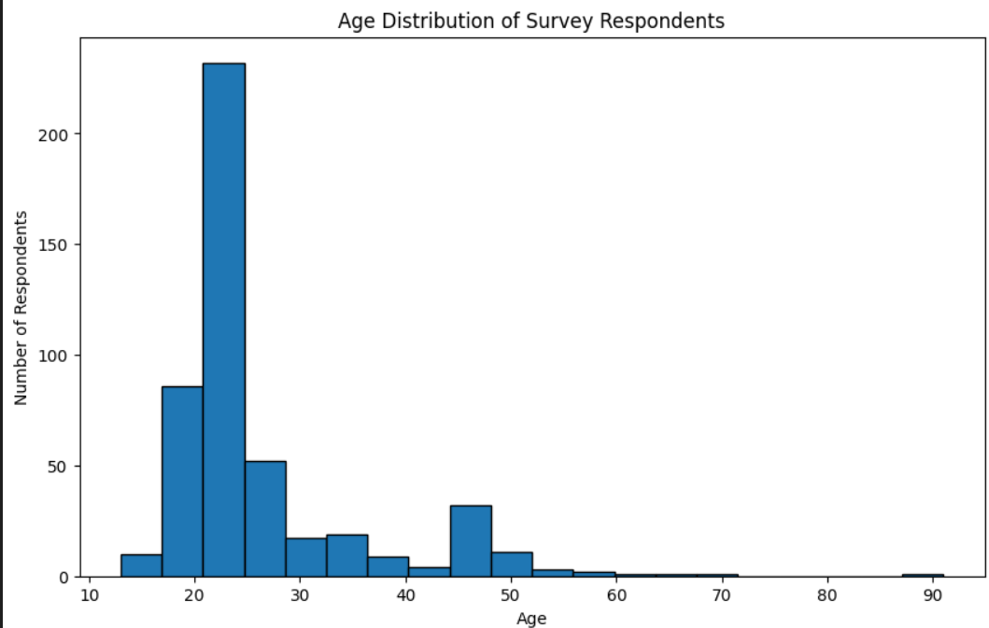

Fig.1 Age Distribution

This graph represents the age distribution amoung users , which age group is focusing more on social media apps.
Users aged between 20 and 25 are tend to be in large number as comparison to others.

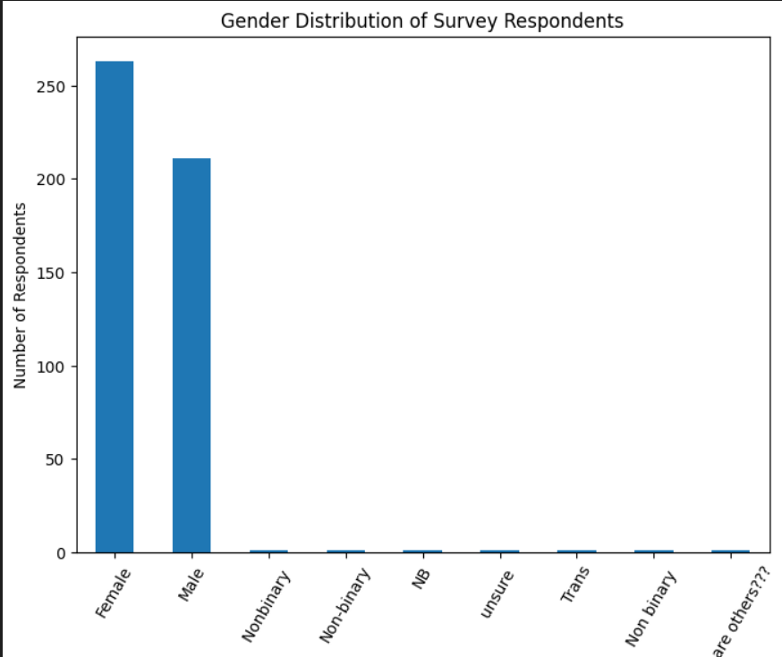

Fig.2 Gender Distribution

This graph represents the gender distribution amoung users , as we can see from the graph Female tends to use more social media as compare to other genders
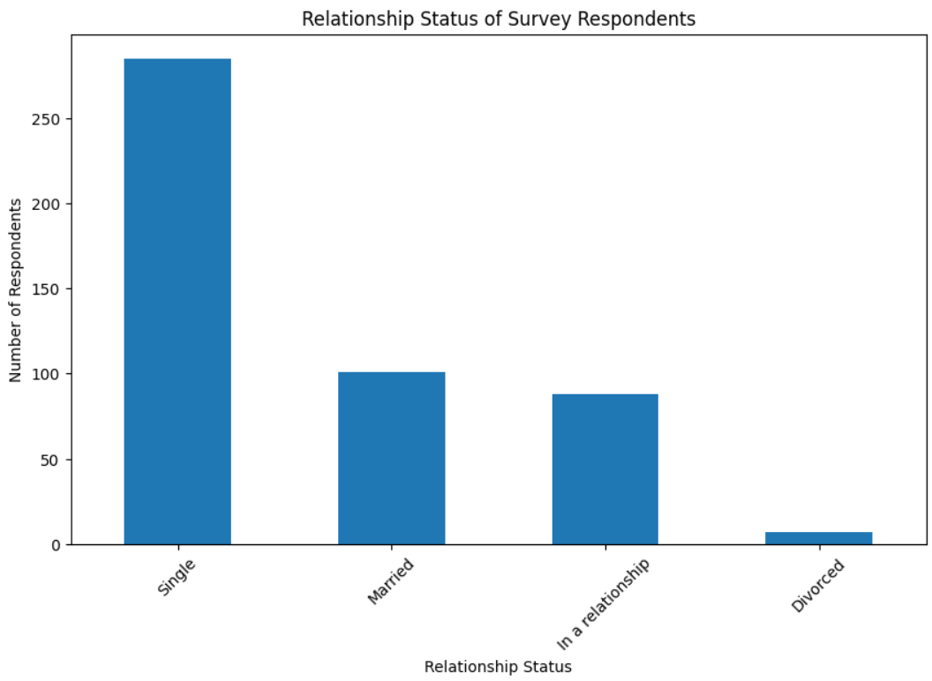
Fig.3 Relationships of users

This graph represents the relationship status amoung users , and from graph it is concluded that single people uses more social media than others.

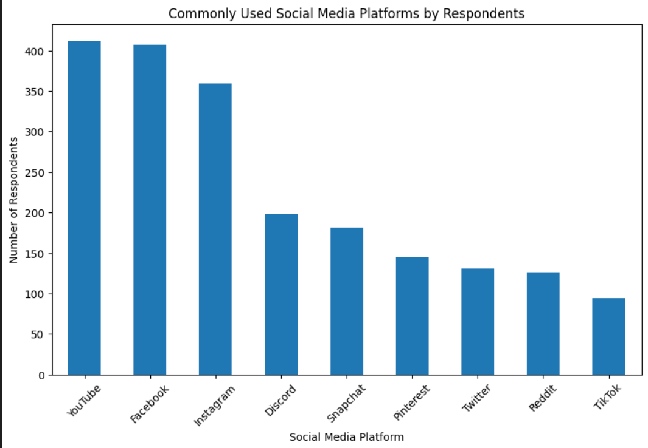

Fig.4 Social Media Platforms Used

From graph we can say that YouTube is the most used social media platform followed by Facebook and Instagram.

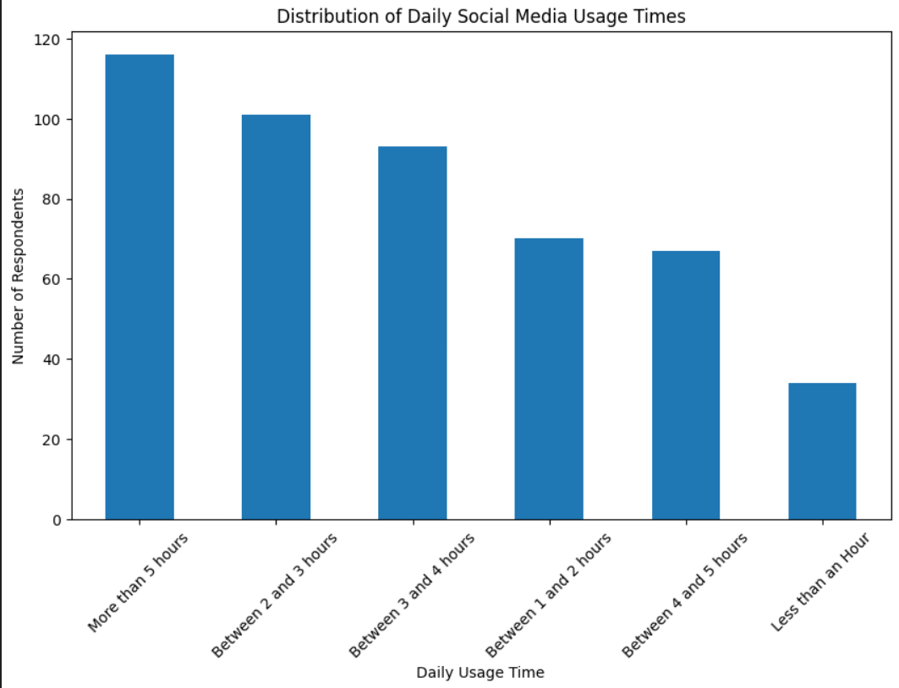

Fig.5 Time Spent

This graph shows the average time duration one spending on social media in his/her whole day.

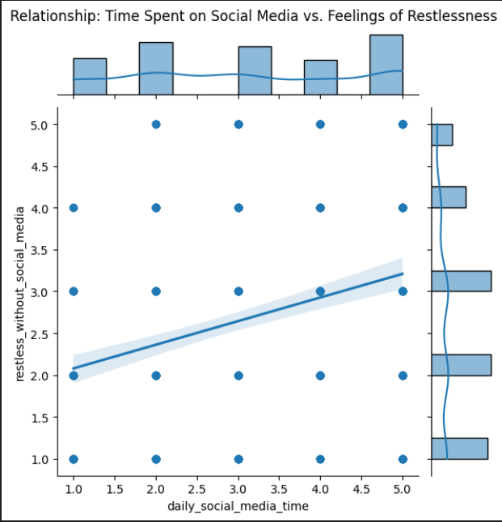

Fig.6 Time vs Restlessness

This graph shows the relationship how more time on social media affecting your feeling of restlessness , form graph it clear more time spend on social media lead to restlessness

